The Organs
The first Organ 1898

When Emmanuel was consecrated in 1898 the singing was accompanied on a pipe organ loaned by Mr. W. Heald: one of the first Churchwardens. The origins of this organ are not yet known for certain but Mr.Heald had come from Didsbury where, at about the same time, an organ had been replaced in St. James Parish Church. Mr Heald obtained an oak screen, now in the north-aisle front of Emmanuel organ, from St. James so it is possible that he had also obtained the old organ from there. Nothing was known about this first organ until, eighty years after it left Emmanuel, its specification and a photograph were discovered in the files of the builders of present instrument.

When the new organ was installed the earlier instrument went to a church in North Shields where it was eventually destroyed by enemy action in the second world war.

The specification of the old organ was:

GREAT
Open Diapason 8
Keraulophon 8
Stopped Diapason 8
Voix Celestes 8
Principal 4
Harmonic Flute 4
Twelfth 22/3
Mixture II
SWELL
Double Diapason 16
Open Diapason 8
Stopped Diapason 8
Principal 4
Mixture III
Cornopean 8
Oboe 8

PEDAL
Open Diapason 16

COUPLERS
Great to Pedal
Swell to Pedal
Swell to Great
Swell to Great Octave

The Present Organ 1914

The present organ, installed in 1914, was built by Harrisons of Durham: one of the country’s most distinguished organ builders whose work is to be found in Westminster Abbey, King’s College, Cambridge and many English cathedrals. It was rebuilt in 2000, by Rushworth and Dreaper of Liverpool, with a modern electric action but preserving entirely Harrisons’ original tonal scheme with the addition of one stop: the Great Mixture.

It’s specification is:

GREAT
Gross Geigen 16
Large Open Diapason 8
Small Open Diapason 8
Hohl Flute 8
Octave 4
Wald Flute 4
Octave Quint 22/3
Super Octave 2
Mixture 19.22.26.29
Tromba 8

SWELL
Open Diapason 8
Lieblich Gedackt 8
Salicional 8
Voix Celestes 8
Gemshorn 4
Mixture 15.19.22
Double Trumpet 16
Trumpet 8
Oboe 8
Clarion 4
Tremulant

CHOIR
Contra Dulciana 16
Violin Diapason 8
Claribel Flute 8
Viola da Gamba 8
Harmonic Flute 4
Clarinet 8
Tromba 8

PEDAL
Open Wood 16
Geigen 16
Sub Bass 16
Octave Wood 8
Flute 8
Trombone 16
Tromba 8

6 thumb pistons Great, 6 Swell,
4 Choir
6 toe pistons Pedal, 6 Swell
reversible thumb pistons to all
inter-departmental couplers
All pistons re-assignable using
‘Scope’.
Digital electric primary action
by Solid State Logic.

Built by Harrison and Harrison 1914
Rebuilt by Rushworth and Dreaper 20

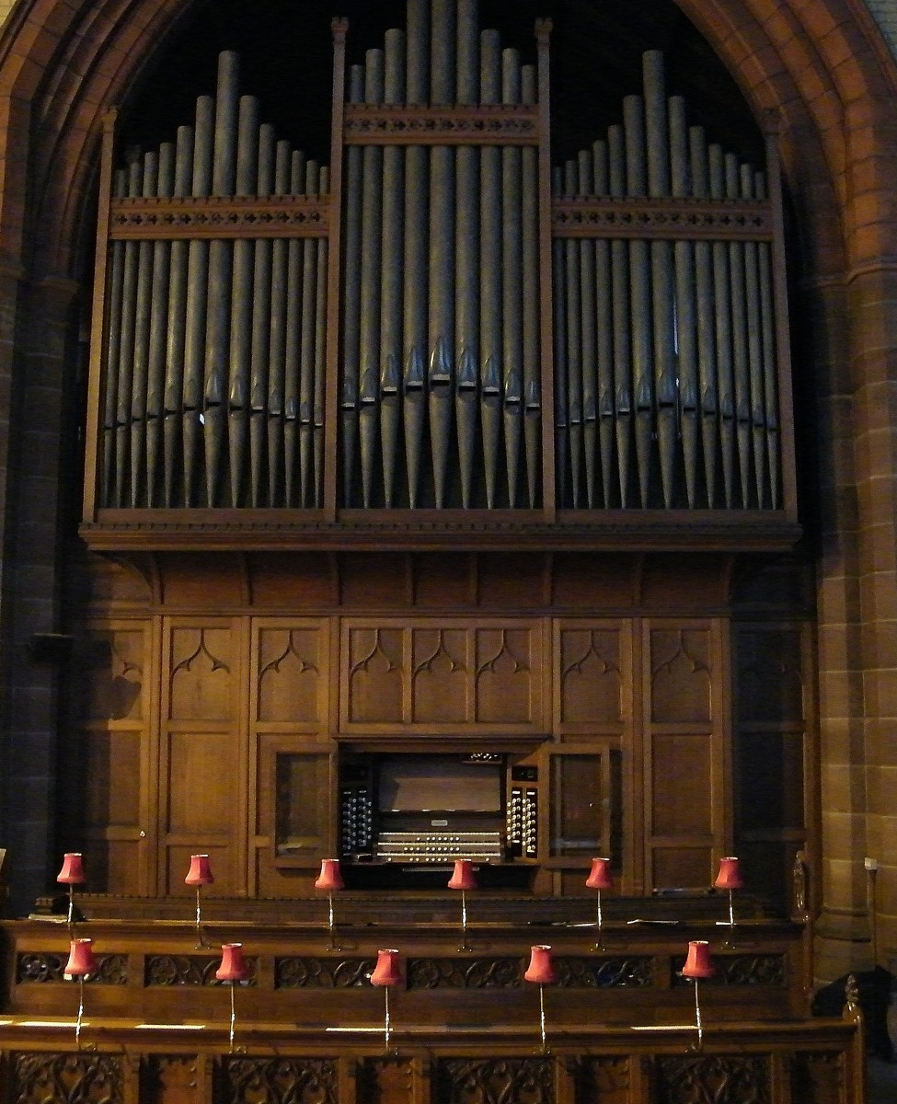

Recent work on the organ in Emmanuel
Those who regularly worship in Emmanuel may have wondered why, during February 2017, our very fine pipe organ was lacking a little of its usual power. The reason was that about seven hundred of its two thousand pipes had been removed. There was nothing wrong with the pipes but they had to be taken out to gain access to the mechanism beneath, which consists of an intricate structure of precisely-fitted wooden parts which must move against each other with tolerances so fine that they are effectively ‘airtight’. Wood is a material so susceptible to damp that the smallest amount of water entering this part of the mechanism can cause very serious problems.
Unfortunately, during the work on the roof, a heavy deluge of rain had caused water to run down the north face of the tower, immediately beneath which stands a section called the ‘Great organ’ (the largest of three manual ‘divisions’, with over seven hundred pipes). Before the work on the roof began the organ builders, had wisely covered the organ with a double layer of polythene sheeting, which had trapped most of the water but left it, on a Sunday afternoon, hanging in great ‘pools’, poised ready to pour into the organ and necessitating immediate action to provide additional covering. Had this precaution not been taken the damage would have been far worse. A sufficient amount of water had however found its way through and into the moving parts below, causing them to jam so that, whilst some pipes would not play at all, others whistled happily to themselves without any bidding from the organist.
Fortunately David Wells (organ builder) and his team moved in quickly to remove all the pipes from the ‘Great’ and take them back to the works for cleaning, leaving the rest of the instrument in use, whilst they made good the damage before leaving the organ once again complete, in tune, and ready for use in good time for Easter.
Readers may be interested to know that the organ, built in 1914, was the work of one of Britain’s leading organ builders, Harrisons of Durham, whose instruments may be heard in Westminster Abbey; King’s College Chapel, Cambridge and many of our cathedrals, and it has remained the only example of Harrison’s work in the town.
Brian Hodge, Emmanuel Organist and Choirmaster

